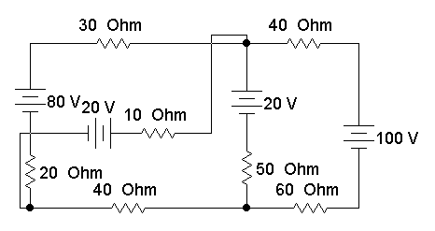
1- By Loop Method find: A
a- The voltage drop and the power dissipated in 10 Ohm resistor. (6 Marks)
b- The voltage of point A. (4 Marks)
2- Convert the voltage sources and repeat using the Node Method. (6 M)
3- Discuss the relation between V and I for a nonlinear resistance. (4 M)
---------------------------------------------------------------------------------------------------------------------------------------------------
1- By Loop Method find: A
a- The voltage drop and the power dissipated in 10 Ohm resistor. (6 Marks)
b- The voltage of point A. (4 Marks)
2- Convert the voltage sources and repeat using the Node Method. (6 M)
3- Discuss the relation between V and I for a nonlinear resistance. (4 M)
---------------------------------------------------------------------------------------------------------------------------------------------------
1- By Loop Method find: A
a- The voltage drop and the power dissipated in 10 Ohm resistor. (6 Marks)
b- The voltage of point A. (4 Marks)
2- Convert the voltage sources and repeat using the Node Method. (6 M)
3- Discuss the relation between V and I for a nonlinear resistance. (4 M)
---------------------------------------------------------------------------------------------------------------------------------------------------
1- By Loop Method find: A
a- The voltage drop and the power dissipated in 10 Ohm resistor. (6 Marks)
b- The voltage of point A. (4 Marks)
2- Convert the voltage sources and repeat using the Node Method. (6 M)
3- Discuss the relation between V and I for a nonlinear resistance. (4 M)
---------------------------------------------------------------------------------------------------------------------------------------------------
1- By Loop Method find: A
a- The voltage drop and the power dissipated in 10 Ohm resistor. (6 Marks)
b- The voltage of point A. (4 Marks)
2- Convert the voltage sources and repeat using the Node Method. (6 M)
3- Discuss the relation between V and I for a nonlinear resistance. (4 M)
---------------------------------------------------------------------------------------------------------------------------------------------------

